**EDA Hotel Booking Analysis**

Shubham Dandnaik

**Abstract:**

Hotel Booking via websites has been surging day by day as it gives us assurance and also with exciting offers its has been in demand it also helps hotels for better management and customers know the hotels prior booking.

We have given the Hotel Booking data which has 119390 rows and 32 columns for year 2015,2016 and 2017. We will be performing various python operations to get insights from the dataset which would help us to take some major decisions in future. From this dataset by performing various operations and by visualization we will find out answers to important questions and to increase the business in coming future.

**Introduction :**

The dataset contain the entries of year 2015,2016 and 2017. Which has 32 columns. Which contains types of hotel like there are two types of hotel City Hotel and Resort Hotel. Also the Adr for different types of rooms also what are related to the cancellation of bookings what is the relation between them.

Hotel industry is highly dependent on people feedbacks , time and date of months , offers available , ADR these are some common factors.

**Problem Statement :**

We have Hotel Booking dataset for year 2015 , 2016 and 2017 which contain bookings of various type of hotels. We have to find out what the various factors affecting the bookings and also what majors to be taken to get more bookings and also to avoid cancellation.

By performing EDA on the given dataset we will find out the the answers for the various type of questions also deriving the meaningful insights from the given dataset which would help us to improve further.

**Data Exploration :**

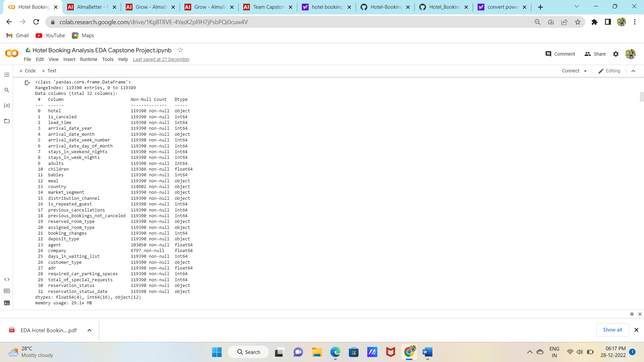

**EDA :**

**Dealing with null values:**

Column named Agent id and Company id has the maximum number of null values so we will drop it also dropping the column named previous bookings not canceled  , previous cancellations , reservation status date which does not contain any helpful information for EDA.

Filling the null values of numeric column Children with 0.

Filling null values of categorical column Country with its mode.

**Data Manipulation :**

Dropping the rows which contains the no of adults and no of children is equal to 0 at same time.

Adding the new column Revenue which we got by multiplying the adr with stays in weekdays plus stays in weekend.

**Data Visualization :**

Data visualization is the visual presentation of data or information. The goal of data visualization is to communicate data or information clearly and effectively to readers. Typically, data is visualized in the form of a chart, infographic, diagram or map .

I have used :

* Bar plot
* Line plot
* Pie chart
* Count plot

**Observations :**

* Most of the people booked City Hotel
* Most number of booking were in year 2016 as it has data of all months 2015 and 2017
* As the bookings were much more higher in City Hotel we generated most revenue from City Hotel
* As per type of customer Transient customers have booked most of the times
* In year 2015 most bookings were in month of September and October. In Year 2016 most bookings were in month of June and October. In year 2017 most bookings were in months of may and June.
* Transient Customer books more often. ¬ From the most Bookings per we can see that in the months of June , July and August has highest bookings
* July and August months has the highest rate of Bookings.
* Portugal , Great Britan and France has booked the hotels most number of times
* Avg Revenue per Day for Resort Hotel is 401.06 which is about 56.23% and for City Hotel 312.15 which is about 43.77%
* Avg revenue per day was highest in months of May and june for City Hotel and July and August for the Resort Hotel.
* Most Cancelled bookings were in year of 2016 ¬ July and August months has the highest cancellations.
* Most Cancellations were done by City Hotel customers.
* BB meal is the preferred type of meal for both the type of hotel
* Very Less number of Customers opted for parking.
* Resort Hotel has the Highest number of repeated customers.

**Conclusion :**

* Most bookings were made for City Hotel but with much less number of bookings Resort Hotel has generated approximate 41% revenue out of Total so focus more on Resort Hotel customers to generate more revenue
* Most of the bookings were from PRT , GBR , France so advertise more in other countries with some special offers target these top countries more.
* Most booked type of rooms were A,D and E and very less bookings for other type of rooms so increase A,D and E type of rooms.
* Major bookings were cancelled in months of July and August try to send exciting offers for the booked customers in these months.
* Most Cancelled bookings were from the customers which hasn't paid the deposits so try to take deposits from more customers.
* There are very less no of repeated customers try to understand customer needs and try to fulfil maximum of it.
* Focus more on Transient type of Customers they are more likely to book.